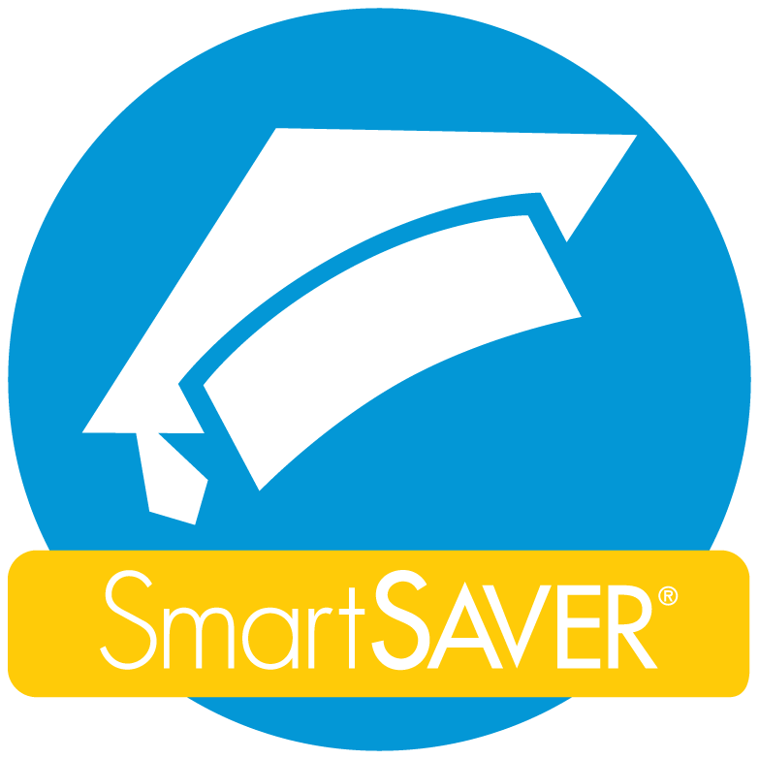
Registered Education Savings Plan (RESP):
Government Incentives for Families
Apply today: StartMyRESP.ca/FSGV
For more information email us at resp@fsgv.ca

 | To receive these incentives, your child must have an RESP account.
Net Family Income | No RESP contributions needed |  | RESP Government Match Savings*  * Up to a lifetime maximum of $7200
 | Canada Learning Bond (CLB)  Lifetime total of $2000 | BC Training and Education Savings Grant (BCTESG)  One-time $1200 grant | Basic Canada Education Savings Grant (CESG) | Additional Canada Education Savings Grant (A-CESG)
Less than $46,605 | IF your child was born January 2004 or later AND parent has ever received the National Child Benefit Supplement (NCBS) | IF child is 6 – 8  years old | Receive a 20%  grant on up to $2500 of contributions per year.  Example: | Receive an additional 20% on the first $500 you save per year.  Example:
 |  |  | Save $100, Get $20 | Save $100, Get $20
 |  |  | Save $500, Get $100 | Save $500, Get $100 MAX
 |  |  | Save $2500, Get $500 MAX | Save $2500, Get $100 MAX
$46,605 -93,208 | X | IF child is 6 – 8  years old | Receive a 20%  grant on up to $2500 of contributions per year.  Example: | Receive an additional 10% on the first $500 you save per year.  Example:
 |  |  | Save $100, Get $20 | Save $100, Get $10
 |  |  | Save $500, Get $100 | Save $500, Get $50 MAX
 |  |  | Save $2500, Get $500 MAX | Save $2500, Get $50 MAX
Greater than $93,208+ | X | IF child is 6 – 8  years old | Receive a 20%  grant on up to $2500 of contributions per year.  Example: | X
 |  |  | Save $100, Get $20
 |  |  | Save $500, Get $100
 |  |  | Save $2500, Get $500 MAX
* 2018 CLB income levels by number of children: 1-3 ($46,605), 4 ($52,583), 5 ($58,586), 6 ($64,589)
Important information on the back
Important Points
- You do not need to contribute any money to a child’s RESP to receive the Canada Learning Bond (CLB) or the BC Training and Education Savings Grant (BCTESG). (See the blue columns on the opposite page for details).

- Each year that you contribute to your child’s RESP, the government will automatically deposit up to $600 of savings grants (Basic Canada Education Savings Grant and Additional Canada Education Savings Grant) into your child’s RESP account. The lifetime maximum government contribution from the Canada Education Savings Grant (CESG) is $7200. (See the white columns on opposite page for details).

FAQS
- Is my child eligible for an RESP?
- A child can be named to an RESP if both the child and a parent have a Canadian Social Insurance Number (SIN).

- When will the free education money go into my child’s RESP account if I apply through StartMyRESP.ca/FSGV?
- Money from the Canada Learning Bond (CLB) will arrive within 8 weeks of applying.
- The BC Training and Education Savings Grant (BCTESG) will arrive 6 to 8 weeks after your eligible child turns 6 years old. If your eligible child is already 6 to 9 years old, the grant will be deposited within 8 weeks of applying.

- Who can open or contribute to an RESP?
- Anyone can open an RESP for a child, as long as they have the SIN number for both the child and parent, and the parent’s consent.
- Anyone can contribute to an existing RESP.

- What if my child already has an RESP?
- If your child already has an RESP, make sure the RESP provider offers the Canada Learning Bond (CLB) and the BC Training and Education Savings Grant (BCTESG) that your child may be eligible for.
- Group plans operated by Canadian Scholarship Trust, Children’s Education Funds, Global, Heritage Education Funds, Knowledge First Financial, and Universitas do not offer the Canada Learning Bond (CLB) or the BC Training and Education Savings Grant (BCTESG) at $0 cost.
- In order to receive the FREE education money for your child, you may apply for another RESP at StartMyRESP.ca/FSGV, even without making any contributions to that account.

- What happens to all that money if my child decides not to do post-secondary education?
- If your child does not continue their education immediately after high school, you can choose to wait before closing the RESP account. The RESP will stay open and available to the child for 36 years.
- You may be able to replace the beneficiary and name another child, depending on your plan.
- You may be able to transfer the money to your own RRSP. Some rules apply. Check your plan details.
- If the RESP is closed for any reason, all grants (CLB, BCTESG, CESG, and A-CESG) must be returned to the government. Any contributions you make to your child’s RESP (and the interest earned on the account) remain your property and will be returned to you.

- What is considered eligible post secondary education?
- A university, college, trade school or other institution recognized by the Minister of Employment and Social Development Canada.
- Full-time and part-time studies are eligible.

- I want to use FSGV’s Start My RESP online application, but my financial institution isn’t an option on the site.
- You don’t have to be an existing customer of one of our financial institution partners (RBC, BMO, TD, CIBC, Scotiabank, Vancity) to complete the Start My RESP application.
- You can open an account with any RESP provider to receive the Canada Learning Bond (CLB) and the BC Training and Education Savings Grant (BCTESG).

- I need help. Who can I contact?
- Staff at Family Services Greater Vancouver can answer questions and provide additional support. Contact us at resp@fsgv.ca.

