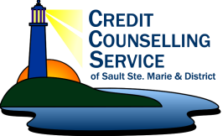

CASE PLAN – ONTARIO FINANCIAL EMPOWERMENT CHAMPION PROGRAM
RESP / CLB SIGN UP

DATE: _____________________

CLIENT NAME: _____________________

CHILD NAME & AGE: ________________________________________________________

DMS CASE NUMBER: _________

CLIENT CONTACT: (TEL) ___________________ (EMAIL):____________________________

SmartSAVER ONLINE FORM COMPLETED: _____Y _____ N

APPOINTMENT DATE WITH FINANCIAL INSTITUTION: ______________

FINANCIAL INSTITUTION CHOSEN: _______________

NEXT STEPS:
CONFIRMATION OF RESP: _____ Y _____ N

CONFIRMATION OF CLB: _____Y _____N

