Do you want FREE MONEY
for your child’s education?

It’s available through the Canada Learning Bond

The Canada Learning Bond is a contribution by the Government of Canada to a child’s Registered Education Savings Plan (RESP).

It provides up to $2,000 in savings for the post-secondary education of eligible children.

Who can get it?

You are eligible if your child was born in 2004 or later and your adjusted net family income is less than $45,916 annually. (See the chart on back of this page for further income eligibility guidelines)

All eligible children receive at least $500 and will receive $100 more for each year they’re eligible up to age 15 or a maximum of $2,000.

How do I get the Canada Learning Bond?

Credit Counselling Service of Sault Ste. Marie can help you apply for the Canada Learning Bond and start an RESP for free!

You’ll need a Social Insurance Number for yourself and your child to complete the application.

There is no cost and you don’t need to contribute any money to get the Canada Learning Bond.

What’s the catch?

The Canada Learning Bond can only be used for education after high school or later in life. This includes part-time or full-time studies at college, university or other qualifying schools in Canada or outside the country. Your child has up to 36 years to use the money.

Wait there is more free money…
As an added bonus, you can get more free money for your child’s education with the Canada Education Savings Grant (CESG). If you are able to contribute your own savings to your RESP, the Government of Canada will give your child an additional 20% of what you deposited for free, up to a maximum of $600 per year. You could receive up to lifetime limit of $7,200 per child in extra free money to top off the savings you are putting in.
Who are we?
Credit Counselling Service of Sault Ste. Marie and District is a not for profit charitable organization and United Way funded partner. We have been helping people with their finances since 1969.

Don’t miss out! Currently 33% of children eligible for this program have applied and there is over 1 billion dollars in unclaimed money!
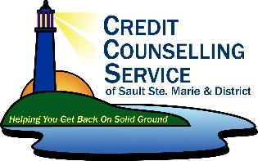
Call us today at (705) 254-1424 for your free appointment to get your application started!

